Statistics

Student Manual

Type of Graph | When To Make It…? | Examples/Notes

Term | Definition | Example / Notes
Source: http://www.census.gov/hhes/income/histinc/p16.html
U.S. Median Income by Educational Attainment (2003 dollars) | 2003 | 15,461 | 28,763 | 50,916 | 61,698 | 9,296 | 15,962 | 31,309 | 41,334
U.S. Median Income by Educational Attainment (2003 dollars) | 2002 | 15,477 | 28,157 | 51,759 | 62,224 | 9,170 | 16,338 | 31,493 | 41,877
U.S. Median Income by Educational Attainment (2003 dollars) | 2001 | 15,166 | 29,453 | 51,943 | 64,387 | 9,193 | 16,279 | 32,186 | 42,340
U.S. Median Income by Educational Attainment (2003 dollars) | 2000 | 15,094 | 29,354 | 52,426 | 63,805 | 9,129 | 16,186 | 32,492 | 43,388
U.S. Median Income by Educational Attainment (2003 dollars) | 1999 | 14,934 | 30,011 | 52,199 | 65,335 | 9,119 | 16,173 | 31,481 | 43,835
U.S. Median Income by Educational Attainment (2003 dollars) | 1998 | 14,168 | 29,914 | 51,561 | 62,871 | 8,919 | 15,538 | 30,898 | 41,575
U.S. Median Income by Educational Attainment (2003 dollars) | 1997 | 13,894 | 29,091 | 47,944 | 60,037 | 8,578 | 15,323 | 30,174 | 31,010
U.S. Median Income by Educational Attainment (2003 dollars) | 1996 | 14,211 | 28,966 | 46,254 | 58,370 | 8,493 | 14,827 | 29,407 | 38,874
U.S. Median Income by Educational Attainment (2003 dollars) | 1995 | 14,052 | 28,007 | 46,796 | 58,825 | 8,506 | 14,439 | 28,846 | 40,166
U.S. Median Income by Educational Attainment (2003 dollars) | 1994 | 13,903 | 27,486 | 47,516 | 57,257 | 8,429 | 13,984 | 28,736 | 39,373
U.S. Median Income by Educational Attainment (2003 dollars) | 1993 | 13,658 | 27,306 | 46,978 | 57,162 | 8,124 | 13,901 | 28,146 | 39,350
U.S. Median Income by Educational Attainment (2003 dollars) | 1992 | 13,329 | 27,811 | 47,213 | 56,912 | 8,142 | 14,007 | 28,760 | 38,764
U.S. Median Income by Educational Attainment (2003 dollars) | 1991 | 13,591 | 28,378 | 47,504 | 56,800 | 8,256 | 14,248 | 27,616 | 39,180
U.S. Median Income by Educational Attainment (2003 dollars) |  | Less than 9th | High Sch. or GED | Bachelors Degree | Masters Degree | Less than 9th | High Sch. or GED | Bachelors Degree | Masters Degree
 |  | Male |  |  |  | Female

Percentage of 25- to 29-year-olds who completed high school, by race/ethnicity and sex: 1993–2003

 | Total |  |  |  | White |  |  |  | Black |  |  |  | Hispanic
Year | Total* | Male | Female |  | Total | Male | Female |  | Total | Male | Female |  | Total | Male | Female
1993 | 87 | 86 | 87 |  | 91 | 91 | 92 |  | 83 | 85 | 81 |  | 61 | 58 | 64
1994 | 86 | 85 | 88 |  | 91 | 90 | 92 |  | 84 | 83 | 85 |  | 60 | 58 | 63
1995 | 87 | 86 | 87 |  | 93 | 92 | 93 |  | 87 | 88 | 85 |  | 57 | 56 | 59
1996 | 87 | 87 | 88 |  | 93 | 92 | 93 |  | 86 | 88 | 85 |  | 61 | 60 | 63
1997 | 87 | 86 | 89 |  | 93 | 92 | 94 |  | 87 | 86 | 88 |  | 62 | 59 | 65
1998 | 88 | 87 | 90 |  | 94 | 93 | 95 |  | 88 | 88 | 88 |  | 63 | 60 | 66
1999 | 88 | 86 | 90 |  | 93 | 92 | 94 |  | 89 | 88 | 89 |  | 62 | 57 | 66
2000 | 88 | 87 | 89 |  | 94 | 93 | 95 |  | 87 | 88 | 86 |  | 63 | 59 | 66
2001 | 88 | 87 | 89 |  | 93 | 93 | 94 |  | 87 | 88 | 87 |  | 63 | 59 | 67
2002 | 86 | 85 | 88 |  | 93 | 92 | 94 |  | 88 | 86 | 89 |  | 62 | 60 | 65
2003 | 87 | 85 | 88 |  | 94 | 93 | 95 |  | 89 | 87 | 89 |  | 62 | 60 | 64
*Included in the totals but not shown separately are other racial/ethnic categories.

SOURCE: U.S. Department of Education, NCES. (2002). The Condition of Education 2002 (NCES 2002–025), Table 25-1.
Minimum Wage in the U.S. 1960-2005

Year | Minimum Wage
1960 | $1.00
1961 | $1.15
1962 | $1.15
1963 | $1.25
1964 | $1.25
1965 | $1.25
1966 | $1.25
1967 | $1.40
1968 | $1.60
1969 | $1.60
1970 | $1.60
1971 | $1.60
1972 | $1.60
1973 | $1.60
1974 | $2.00
1975 | $2.10
1976 | $2.30
1977 | $2.30
1978 | $2.65
1979 | $2.90
1980 | $3.10
1981 | $3.35
1982 | $3.35
1983 | $3.35
1984 | $3.35
1985 | $3.35
1986 | $3.35
1987 | $3.35
1988 | $3.35
1989 | $3.35
1990 | $3.80
1991 | $4.25
1992 | $4.25
1993 | $4.25
1994 | $4.25
1995 | $4.25
1996 | $4.75
1997 | $5.15
1998 | $5.15
1999 | $5.15
2000 | $5.15
2001 | $5.15
2002 | $5.15
2003 | $5.15
2004 | $5.15
2005 | $5.15
Minimum Wage in the U.S. 1960-2005 (Adjusted to 2005 Dollars)

Year | Minimum Wage | Minimum Wage (2005 Dollars)
1960 | $1.00 | $6.58
1961 | $1.15 | $7.52
1962 | $1.15 | $7.42
1963 | $1.25 | $7.96
1964 | $1.25 | $7.86
1965 | $1.25 | $7.76
1966 | $1.25 | $7.53
1967 | $1.40 | $8.19
1968 | $1.60 | $8.99
1969 | $1.60 | $8.51
1970 | $1.60 | $8.04
1971 | $1.60 | $7.73
1972 | $1.60 | $7.48
1973 | $1.60 | $7.05
1974 | $2.00 | $7.94
1975 | $2.10 | $7.64
1976 | $2.30 | $7.90
1977 | $2.30 | $7.42
1978 | $2.65 | $7.93
1979 | $2.90 | $7.80
1980 | $3.10 | $7.35
1981 | $3.35 | $7.20
1982 | $3.35 | $6.78
1983 | $3.35 | $6.57
1984 | $3.35 | $6.30
1985 | $3.35 | $6.08
1986 | $3.35 | $5.97
1987 | $3.35 | $5.76
1988 | $3.35 | $5.53
1989 | $3.35 | $5.28
1990 | $3.80 | $5.68
1991 | $4.25 | $6.10
1992 | $4.25 | $5.92
1993 | $4.25 | $5.74
1994 | $4.25 | $5.60
1995 | $4.25 | $5.45
1996 | $4.75 | $5.92
1997 | $5.15 | $6.27
1998 | $5.15 | $6.17
1999 | $5.15 | $6.04
2000 | $5.15 | $5.84
2001 | $5.15 | $5.68
2002 | $5.15 | $5.59
2003 | $5.15 | $5.47
2004 | $5.15 | $5.33
2005 | $5.15 | $5.15

sources: www.epinet.org, http://oregonstate.edu/dept/pol_sci/fac/sahr/sahr.htm

Area Name/Zip Code | Percent of Brooklyn’s Population | Percent of Brooklyn’s Military Recruits | Percent of Population that are People of Color
11201 - Brooklyn Heights/Cobble Hill | 2.9 | 1.5 | 36.8
11203 - East Flatbush | 2.5 | 6.6 | 96.6
11204 - Parkville/Bensonhurst | 3.4 | 0.7 | 26.2
11205 - Fort Greene | 3.5 | 1.2 | 77.3
11206 - Williamsburg/Bedford-Stuyvesant | 2.6 | 4.1 | 75.3
11207 - East New York | 3.4 | 4.8 | 90.8
11208 - Cypress Hills | 2.5 | 6.8 | 84.8
11209 - Bay Ridge | 2.3 | 1.9 | 22.6
11210 - Vanderveer/Flatbush | 1.4 | 2.6 | 67.5
11211 - Williamsburg | 3.0 | 1.5 | 36.9
11212 - Brownsville | 3.5 | 6.8 | 96.6
11213 - Brower Park/Crown Heights | 3.8 | 3.7 | 86.7
11214 - Bath Beach/Bensonhurst | 3.1 | 1.4 | 28.3
11215 - Park Slope/Windsor Terrace | 1.6 | 1.7 | 32.0
11216 - Bedford-Stuyvesant | 3.2 | 2.9 | 97.6
11217 - Park Slope/Gowanus | 2.1 | 1.7 | 50.6
11218 - Kensington/Windsor Terrace | 2.6 | 1.7 | 44.0
11219 - Borough Park | 4.3 | 1.0 | 28.2
11220 - Sunset Park | 1.6 | 4.8 | 64.6
11221 - Bushwick/Bedford-Stuyvesant | 3.2 | 3.1 | 91.2
11222 - Greenpoint | 3.6 | 1.7 | 19.8
11223 - Gravesend/Homecrest | 1.3 | 2.7 | 26.6
11224 - Coney Island | 1.1 | 1.7 | 44.0
11225 - Crown Heights | 2.5 | 4.3 | 92.7
11226 - Flatbush | 3.5 | 6.1 | 93.3
11228 - Dyker Heights | 3.1 | 0.5 | 19.2
11229 - Homecrest/Madison | 3.9 | 2.6 | 24.6
11230 - Midwood | 2.0 | 1.7 | 26.8
11231 - Carroll Gardens/Red Hook | 2.0 | 0.3 | 37.3
11232 - Industry City/Sunset Park | 0.6 | 1.0 | 56.6
11233 - Stuyvesant Heights | 2.9 | 3.6 | 96.5
11234 - Flatlands/Mill Basin | 2.5 | 2.4 | 41.8
11235 - Sheepshead Bay/Brighton Beach | 3.4 | 2.0 | 23.4
11236 - Canarsie | 3.5 | 5.1 | 82.4
11237 - Bushwick | 2.6 | 1.0 | 72.6
11238 - Prospect Heights | 3.4 | 1.7 | 82.8
11239 - Starrett City | 2.5 | 1.2 | 62.1
sources: Peaceworks Magazine, www.Infoshare.org, www.CounterRecruitmentGuide.org
The text on the bottom of this ad says: “More than 98% of all Chevy trucks sold in the last 10 years are still on the road… Chevrolet. The Most Dependable, Longest-Lasting Trucks.”

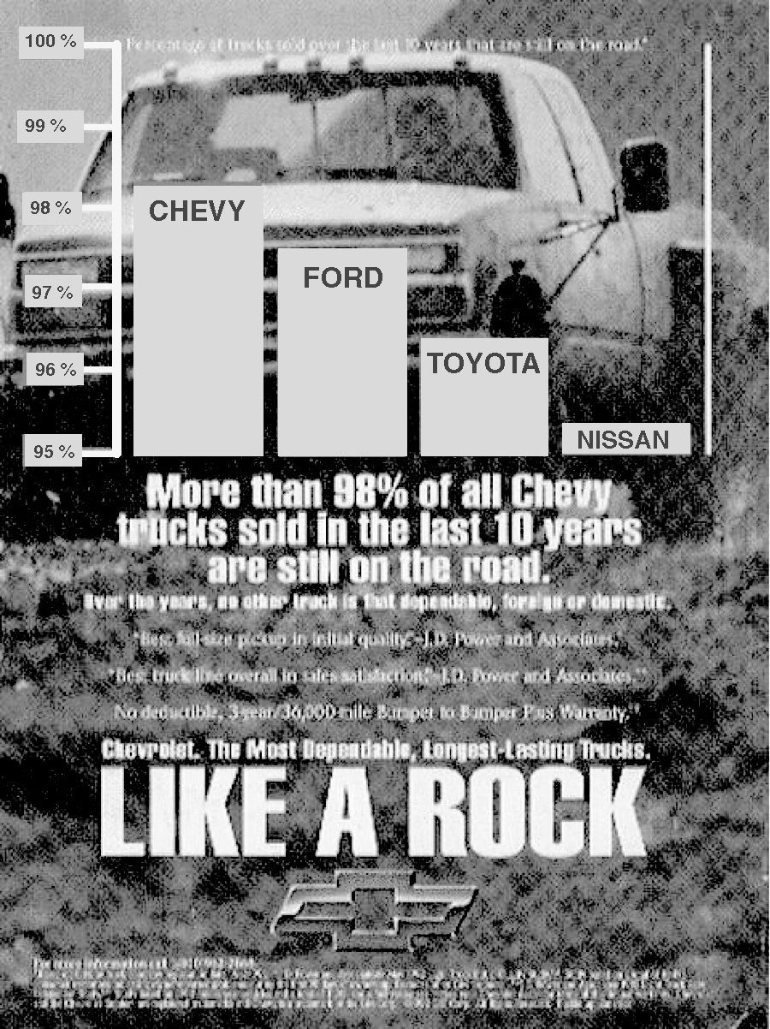

In the space below, write about what message you think Chevy is trying to get across in this ad. What information are they using to try and convince people to buy their product over another?

If you looked only at the size of the bars for each company, how does Chevy compare to the other cars?

What percent of Chevy’s are still on the road? ___________________

Ford? ___________________ Toyota? ___________________ Nissan? ___________________

If you look only at the percent of each car that is still on the road, how does Chevy compare to the other car companies?

On a separate piece of graph paper, redraw the graph using the percents you wrote above. The scale on your Y-Axis should go from 0% to 100%, and should be as tall as the paper allows.

Looking at your new graph, do you think that it is fair for Chevy to imply that their cars are much better than the other companies? Explain why or why not.

On a piece of graph paper, draw this graph again but have your Y-Axis go from 0 – 100.

For each of the terms below, determine which are Quantitative and which are Categorical

The names of all the students in this school __________________________

The ages of everyone in the Senior class __________________________

How many times, on average, it rained during September since 1950 __________________________

The percentage of teenagers in each state who have credit cards __________________________

The names of the different Credit Cards that teenagers use __________________________

Based on the chart below, determine which variables (the terms in bold) are Categorical measurements and which are Quantitative.

Name | Job Type | Age | Gender | Race | Salary
Jose Cedillo | Technician | 27 | Male | Latino | 52,300
Tonia Chambers | Manager | 42 | Female | Latino | 112,800
Chris Chen | Technician | 31 | Male | Asian | 53,500

Categorical: Quantitative:

Give several examples of data that are:

Categorical: Quantitative:

In the space below, write down the name of each person in the class, including yourself and your teachers. Next to each person’s name, write how many letters are in the name. Include anyone who might be absent as well.

A Frequency Table is a chart that measures how often each possible answer occurs. Fill in the following Frequency Table based on the information from above.

Letters in first name | 3 | 4 | 5 | 6 | 7 | 8 | 9 | 10 | 11
Number of people

Construct a Dot-Plot from the information from the Frequency Table you made:
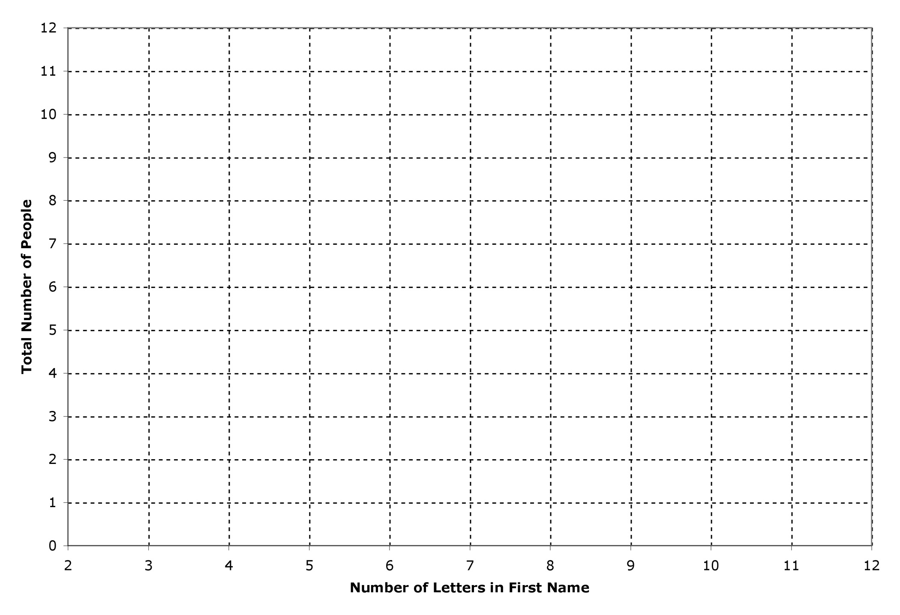

Describe the distribution of the dots – What shape do they make? How are they spread out? Are they symmetrical or asymmetrical?

What does this distribution mean about the variation in the ages of people in this class?

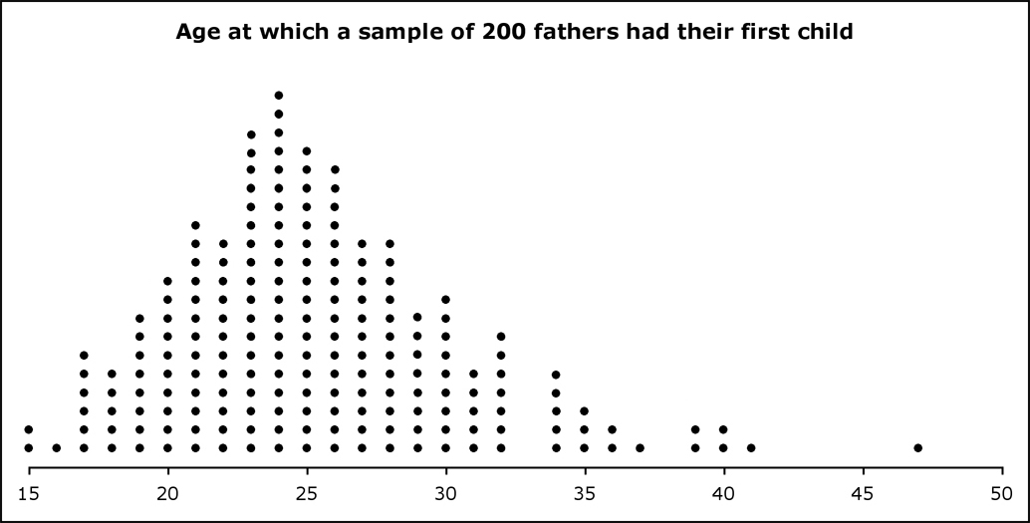

Explain what each of the dots in this dot-plot represent

At what age did the most fathers have their first child? How do you know?

How many fathers had their first child when they were 33? How do you know?

Describe the pattern of the distribution of the dots, and explain what this means about the amount of variation in this data.

On the back of this paper, construct a Frequency Table from this dot plot.

Average SAT Scores and Participation Rates, by State, 2005

State | Percent Participation | Average SAT Score |  | State | Percent Participation | Average SAT Score
Alabama | 10% | 1130 |  | Montana | 31% | 1080
Alaska | 52% | 1040 |  | Nebraska | 8% | 1150
Arizona | 33% | 1060 |  | Nevada | 39% | 1010
Arkansas | 6% | 1120 |  | New Hampshire | 81% | 1050
California | 50% | 1030 |  | New Jersey | 86% | 1020
Colorado | 26% | 1120 |  | New Mexico | 13% | 1110
Connecticut | 86% | 1030 |  | New York | 92% | 1010
Delaware | 74% | 1010 |  | North Carolina | 74% | 1010
Florida | 65% | 1000 |  | North Dakota | 4% | 1200
Georgia | 75% | 990 |  | Ohio | 29% | 1080
Hawaii | 61% | 1010 |  | Oklahoma | 7% | 1130
Idaho | 21% | 1090 |  | Oregon | 59% | 1050
Illinois | 10% | 1200 |  | Pennsylvania | 75% | 1000
Indiana | 66% | 1010 |  | Rhode Island | 72% | 1010
Iowa | 5% | 1200 |  | South Carolina | 64% | 990
Kansas | 9% | 1170 |  | South Dakota | 5% | 1180
Kentucky | 12% | 1120 |  | Tennessee | 16% | 1140
Louisiana | 8% | 1130 |  | Texas | 54% | 1000
Maine | 75% | 1010 |  | Utah | 7% | 1120
Maryland | 71% | 1030 |  | Vermont | 67% | 1040
Massachusetts | 86% | 1050 |  | Virginia | 73% | 1030
Michigan | 10% | 1150 |  | Washington | 55% | 1070
Minnesota | 11% | 1190 |  | West Virginia | 20% | 1030
Mississippi | 4% | 1120 |  | Wisconsin | 6% | 1120
Missouri | 7% | 1180 |  | Wyoming | 12% | 1090
Source: www.collegeboard.com

Which state(s) had the highest and lowest average SAT scores, and what were those scores?

Which state(s) had the highest and lowest participation rates, and what were the rates?

How do these states compare to each other when looking at both sets of data?

Here is a Dot-Plot of all 50 States based on their SAT scores:

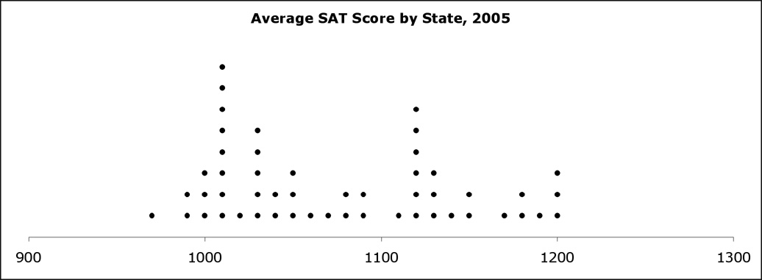

What does each of these dots represent?

Is it possible to determine if there is a connection between “Average SAT Score” and “Participation Rate” by looking at this Dot Plot? Why or why not? If it possible, what connection does it show?

Divide the data into 2 groups: States with more than 25% of students who took the SAT, and States 25% of students or less who took the SAT. Then fill in the Frequency Tables below for each group.

25% or Less  Participation |  |  | More than 25%  Participation
Average SAT Score | Count |  | Average SAT Score | Count
1200 |  |  | 1200
1190 |  |  | 1190
1180 |  |  | 1180
1170 |  |  | 1170
1160 |  |  | 1160
1150 |  |  | 1150
1140 |  |  | 1140
1130 |  |  | 1130
1120 |  |  | 1120
1110 |  |  | 1110
1100 |  |  | 1100
1090 |  |  | 1090
1080 |  |  | 1080
1070 |  |  | 1070
1060 |  |  | 1060
1050 |  |  | 1050
1040 |  |  | 1040
1030 |  |  | 1030
1020 |  |  | 1020
1010 |  |  | 1010
1000 |  |  | 1000
990 |  |  | 990
980 |  |  | 980
970 |  |  | 970
Now make a Dot-Plot for each of the two Frequency Tables, and give each chart a Title:

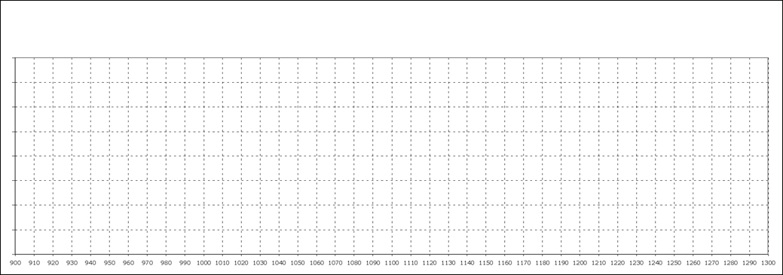

By looking at your graphs, does there seem to be a relationship between the percent of students in a state who are taking the SAT and the scores that those students are getting? What evidence do you have to prove your answer?

What is 15% of 100? What is 15% of 200?

What is 27% of 2,645? What is 75% of 32.8?

What is 6% of 20? What is 10.5% of 400?

What is 20% of 40? What is 40% of 20?

What is 25% of 25% of 25% of 4000? 48 is what percent of 400?

32 is what percent of 640? What is 150% of 14?

Three friends find $150. Paul takes 15%, Lola takes 82%, and Marianna takes the rest. How much money does each person get?

Jason takes his check for $142 to a Check Casher. The check casher’s fee is 15% of Jason’s check. How much money does Jason get back?

Last year Juan’s car was worth $8,500. This year it decreased in value by 13%. How much is it worth now?

Last year the apartment Juan owns was worth $155,000. This year it increased in value by 6%. How much is it worth now?

Option A: Take 10% off the original price, and then take another 10% off the new price. Option B: Take 20% off the original price. Which is a better option? Explain your answer with an example.

City A has an Asthma rate of 120 cases per 420 people. City B has an Asthma rate of 4,300 cases per 15,050 people. Which City has a higher rate of Asthma? Explain your answer.

Find the value of X in the equivalent rates below.

372 out of every 10,000 people in Ricardo City are 3 years old or less. If there are 129,645 people in Ricardo City, how many are more than 3 years old?
In City X, 0.095% of the residents are homeless. In City Y, 0.18% of the residents are homeless. Change these two values into rates that make them easier (and possible) to compare.

Which of the following cities is more affected by AIDS? Explain your answer.

City | Total Population | People with AIDS
A | 456,789 | 12,345
B | 255,400 | 10,216

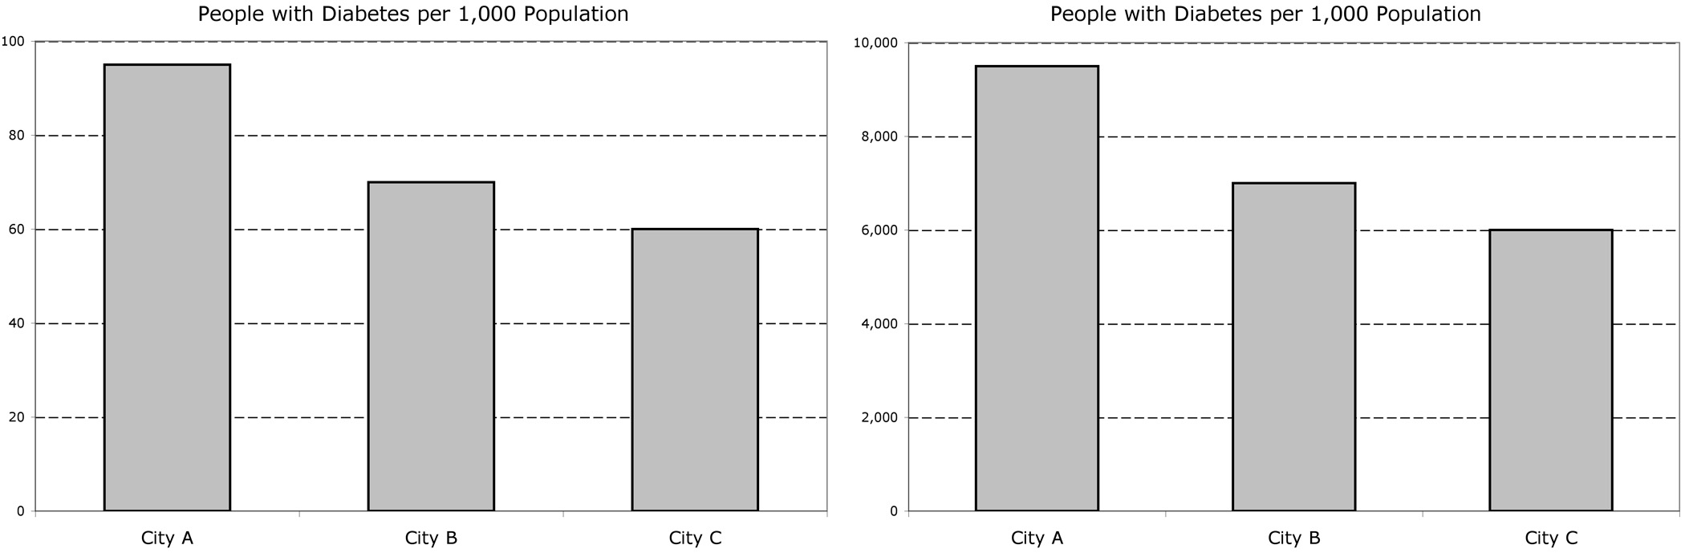

These are graphs of data about Diabetes in Cities A, B, and C. Why are the two graphs the same?

Studies say the average American family has 2.5 kids. Explain why this can make sense even though it is not possible for a family to actually have 2.5 kids.

There are 56,485 fans at the Soccer stadium. 22,412 are rooting for Mexico. How many out of every 10,000 fans are rooting for Mexico?

27 out of every 100,000 people have two different colored eyes. If there are 285 million people in the U.S., approximately how many have two different colored eyes?

Look back at the list we made of each student’s name, and how many letters were in their names, and fill in the Frequency Table you made here:

Letters in first name | 3 | 4 | 5 | 6 | 7 | 8 | 9 | 10 | 11
Number of people

Instead of using dots to represent the number of people for each value on the X axis, use a bar whose height is equivalent to the frequency of the response. Construct a Bar Graph in the space below. Make sure to label the axis’.



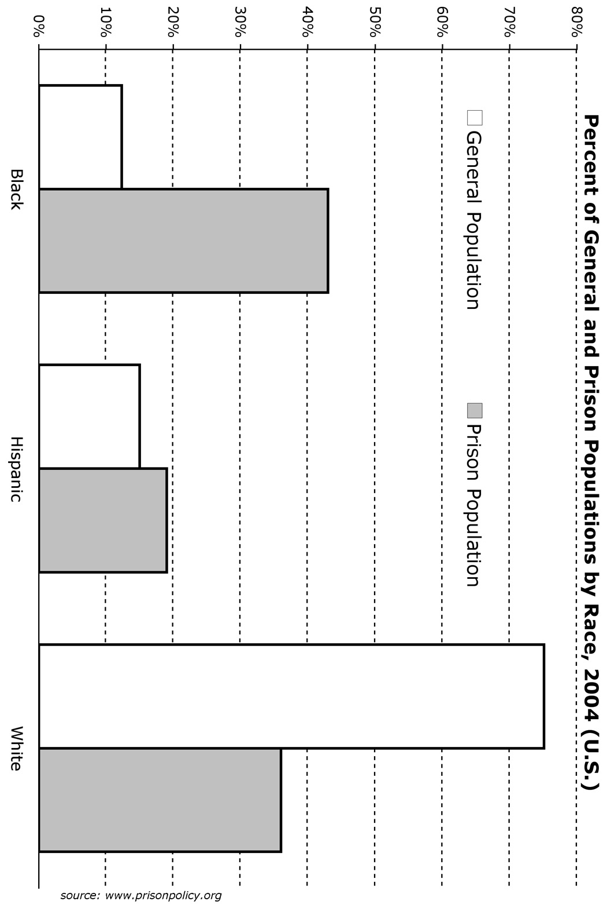

In 2004, what percent of __________ were Black, Hispanic and White

Incarcerated U.S. Population

Add up the totals for the percent of each race that is incarcerated. Do you get 100%? If not, why do you think their sum isn’t exactly 100%?

Add up the totals for the percent of each race that is in the U.S. population. Do you get 100%? If not, why do you think their sum isn’t exactly 100%?

In 2004, there were approximately 288,378,137 total people in the U.S., and 2,131,200 of them were in prison. Based on the graph:

1. Estimate how many people of each race there were in the U.S. in 2004.

2. Estimate how many people of each race there were in prison in 2004.

3. Determine what percent of the total population of each race is currently incarcerated.

The following chart, based on data from the 2000 Census, compares ‘Hispanics’ in the United States whose ancestors came from 9 different countries. This is how people who self-identified as ‘Hispanic’ listed their Race.

Ancestry | Total People | Total White | Total Black | Total Other
Ecuadorian | 191,198 | 97,511 | 9,560 | 84,127
Columbian | 378,726 | 234,810 | 7,575 | 136,341
Panamanian | 92,013 | 30,364 | 37,725 | 23,923
Honduran | 131,066 | 57,669 | 18,349 | 55,048
Guatemalan | 268,779 | 110,199 | 2,688 | 155,892
Dominican | 520,151 | 140,441 | 156,045 | 223,665
Cuban | 1,053,197 | 863,622 | 21,064 | 168,512
Puerto Rican | 2,651,815 | 1,166,799 | 265,182 | 1,219,835
Mexican | 13,393,208 | 6,830,536 | 133,932 | 6,428,740

Your group will be assigned one or two of these countries, and your task is to make a Segmented Bar graph for each.

Before you make your graph, you will need to convert your data into percents.

From the top down, please use the following colors:

Red ….…… ( % Other )

Orange …... ( % Black )

Yellow …… ( % White )

When you’re done, cut out your Segmented Bar Graphs and hang them up on the poster on the wall.
Please put the “% Other” on top, the “% Black” in the middle, and the “% White” on the bottom.

100 %

0 %

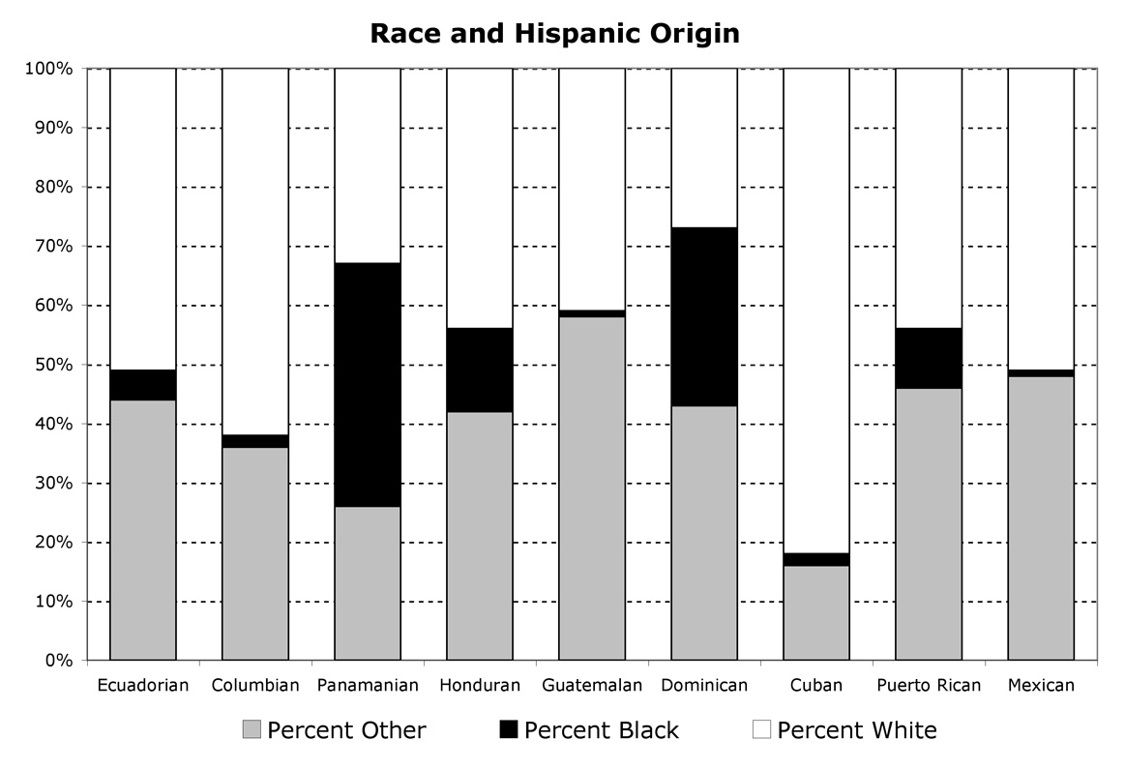
Source: 1990 Census, Table: P011. HISPANIC ORIGIN - Universe: Persons

Approximately what percent of Columbians in the U.S. are Black? _______________

Approximately what percent of Cubans in the U.S. are neither White nor Black? __________________

Which country has the highest percent of people who are Black? _____________ What percent? ______

Which country has the highest percent of people who are White? _____________ What percent? ______

Which country has the highest percent of people who are ‘Other’? _____________ What percent? _____

There were 13,393,208 Mexicans in the U.S. in 2000 who were counted in the census, and of them, 6,830,536 identify as White. What is the rate of Mexicans who consider themselves White out of every 10,000 people?

Is it possible to determine from this graph the average number of people who identify as ‘Other’ from all of these countries? If it is possible, find the average. If it is not possible, explain why it isn’t.

Use the website www.Infoshare.org to fill in the following tables:

Brooklyn Zip Codes | Median Household Income (1999)
11201
11205
11211
11222
11231
11237

Borough | Total Population | Total Number of 18 Year-Olds
Brooklyn
Bronx
Manhattan
Queens
Staten Island

For all of New York City
Total Births in 1999
Total Reported Felonies (Crime) in 2001
Number of Documented Immigrants from Mexico, 2002

Using www.infoshare.org find a set of data to make a Bar Graph with. Here are some things to remember about what data to use:
- You need to pick a geographic area, for example: zip code, borough, etc.
- You should pick 1 set of data (or 2 related sets of data) about your area, such as “the number of people who…”

Also, think about whether it makes sense to use rates (ex. the “the number of people out of 10,000 who…”) or percents (instead of totals) for your table? If so, you will need to find the total number of people in the areas you’re comparing.

In the space below, make a chart of the data you are going to make a graph of:

Once your chart is done, please make a Bar Graph of your data. You can make any type of Bar Graph that you want.
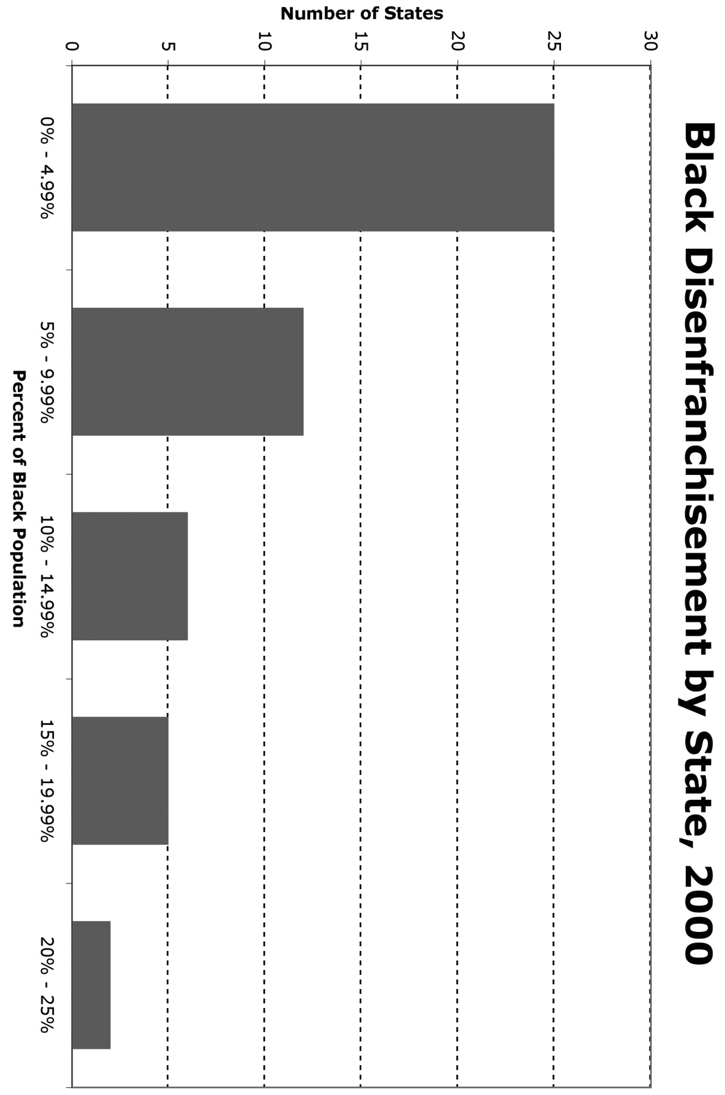
Source: http://www.prisonpolicy.org/atlas/black_vap_disenfranchisement_2000.html

Remember when we made a Frequency Table that looked at how many people in the class had names with certain amounts of letters? We made a tally for each size name. Now we’re going to combine names into groups of multiple sizes.

Number of Letters in a Name | 3, 4, or 5 letters | 6, 7, or 8 letters | 9, 10, or 11 letters
Amount of People

Now use this graph to make a Histogram of this chart. Make sure to label both of the axes.

Percent of Population that is Poor, By State (2000)

Your task is to make a Histogram Graph from this data.

You should decide how many groups to divide the data into… But make sure that each group has the same range between its highest/lowest values.

State | Percent of Population Below the Poverty Line |  | State | Percent of Population Below the Poverty Line
Alabama | 13% |  | Montana | 11%
Alaska | 7% |  | Nebraska | 7%
Arizona | 10% |  | Nevada | 8%
Arkansas | 12% |  | New Hampshire | 4%
California | 11% |  | New Jersey | 6%
Colorado | 6% |  | New Mexico | 15%
Connecticut | 6% |  | New York | 12%
Delaware | 7% |  | North Carolina | 9%
Florida | 9% |  | North Dakota | 8%
Georgia | 10% |  | Ohio | 8%
Hawaii | 8% |  | Oklahoma | 11%
Idaho | 8% |  | Oregon | 8%
Illinois | 8% |  | Pennsylvania | 8%
Indiana | 7% |  | Rhode Island | 9%
Iowa | 6% |  | South Carolina | 11%
Kansas | 7% |  | South Dakota | 9%
Kentucky | 13% |  | Tennessee | 10%
Louisiana | 16% |  | Texas | 12%
Maine | 8% |  | Utah | 7%
Maryland | 6% |  | Vermont | 6%
Massachusetts | 7% |  | Virginia | 7%
Michigan | 7% |  | Washington | 7%
Minnesota | 5% |  | West Virginia | 14%
Mississippi | 16% |  | Wisconsin | 6%
Missouri | 9% |  | Wyoming | 8%

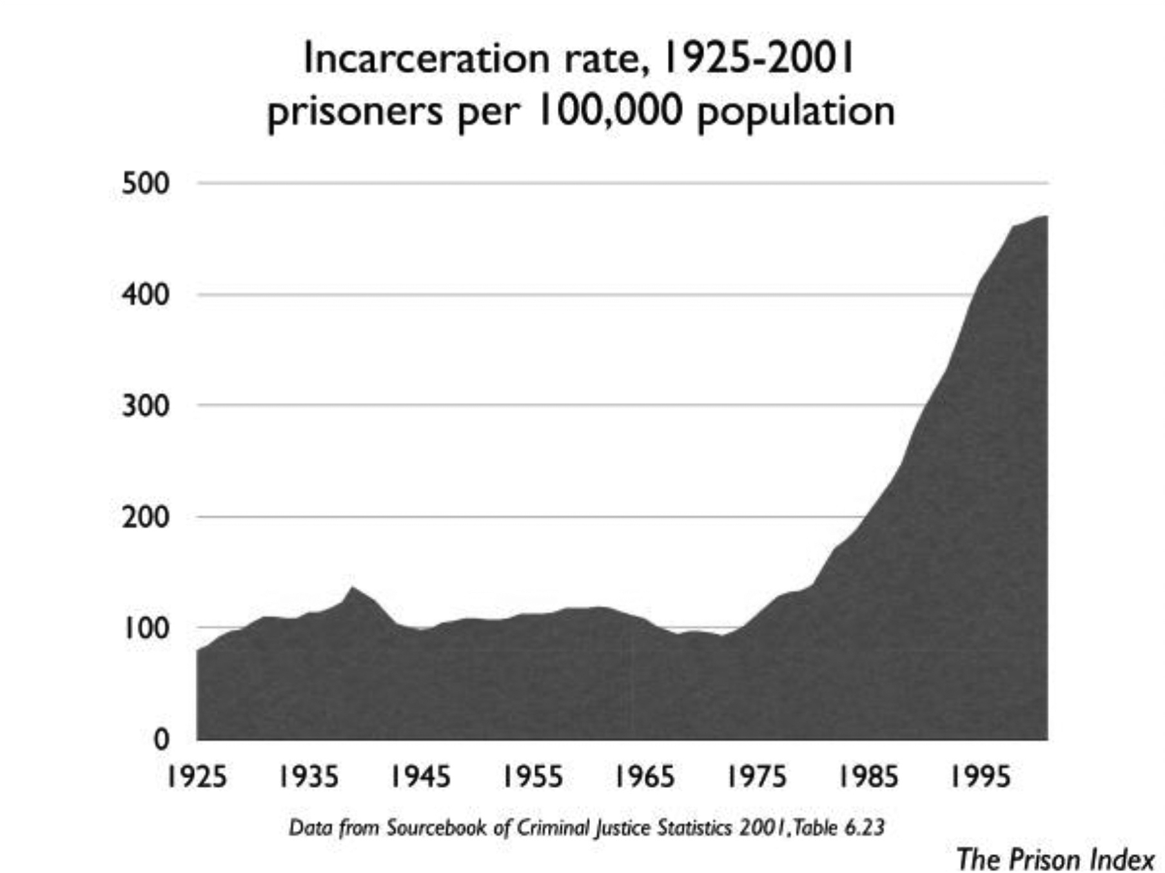

- What is this type of graph called?

- Why did the person who made this graph use this type of graph to represent this information?

- What happened to the incarceration rate between 1925 and 1975? What happened to the incarceration rate between 1975 and 2001?


- Is it possible to tell from this graph the total number of people who were in prison each year? If so, pick a year and determine how many people were in prison.

- If we wanted to understand the history of imprisonment in this country, why might a graph of the rate of incarceration be more useful than a graph of the total number of people incarcerated?

- Come up with 3 possible reasons why the incarceration rate might have gone up so much and/or gone up so quickly between 1975 – 2001.

1 )

2)

3)

In this activity, you will need to first find a set of data to make a Line Graph with, and then make a graph. Your graph needs to include two sets of data so that you are graphing two lines on the same graph.

STEP 1: Find data to make a Line Graph. Think carefully about what type of data is best to make a Line Graph with. Below are some websites where you might find useful data. Or, you can search for your own data online. Remember, you need two sets of data to graph.

STEP 2: Once you’ve found data to graph, you need to make a graph on chart paper. Your graph needs to include a table with your data

http://www.radicalmath.org/browse_type.php?t=chart - NOTE: NEED 2 ADD MORE
- Black and Hispanic-owned Businesses in the US
- Dropout Rates
- Educational Attainment by Race, Gender, Ethnicity
- Employment Status
- Health Insurance
- National Income Data
- National Poverty Data

STEP 3: Each person in your group needs to answer the following questions and turn them in:

- What is the data that you used for your graph?
- Describe what is happening to each of the lines on your graph over time?
- What does your Graph tell you about your data?

Minimum Wage in the U.S. 1960-2005
(Adjusted to 2005 Dollars)

Make a line graph with the following data. You should make one graph that includes both sets of data.

Year | Minimum Wage | Minimum Wage (2005 Dollars)
1960 | $1.00 | $6.58
1965 | $1.25 | $7.76
1970 | $1.60 | $8.04
1975 | $2.10 | $7.64
1980 | $3.10 | $7.35
1985 | $3.35 | $6.08
1990 | $3.80 | $5.68
1995 | $4.25 | $5.45
2000 | $5.15 | $5.84
2001 | $5.15 | $5.68
2002 | $5.15 | $5.59
2003 | $5.15 | $5.47
2004 | $5.15 | $5.33
2005 | $5.15 | $5.15

sources: www.epinet.org, http://oregonstate.edu/dept/pol_sci/fac/sahr/sahr.htm

Year | Employed People in the U.S. (thousands) | Unemployed People in the U.S. (thousands) | Rate of Employed to Unemployed People in the U.S. (thousands)
2003 | 70,415 | 4,209
2002 | 69,734 | 3,896
2001 | 69,776 | 3,040
2000 | 68,580 | 2,350
1999 | 67,761 | 2,433
1998 | 67,134 | 2,580
1997 | 66,524 | 2,826
1996 | 64,897 | 3,147
1995 | 64,085 | 3,239
1994 | 63,294 | 3,627
1993 | 62,335 | 4,287
1992 | 61,496 | 4,717
1990 | 61,678 | 3,239
1985 | 56,562 | 3,715
1980 | 53,101 | 3,353
1970 | 45,581 | 1,638

Looking on the chart, would you say the U.S. is doing better or worse than in the past at making sure there are high levels of employment? What is your evidence?

Calculate the rate of employed to unemployed people in the U.S. to the nearest whole number.
Construct a Line Graph with two lines: (1) the number of employed people, and (2) the rate of employed to unemployed people.

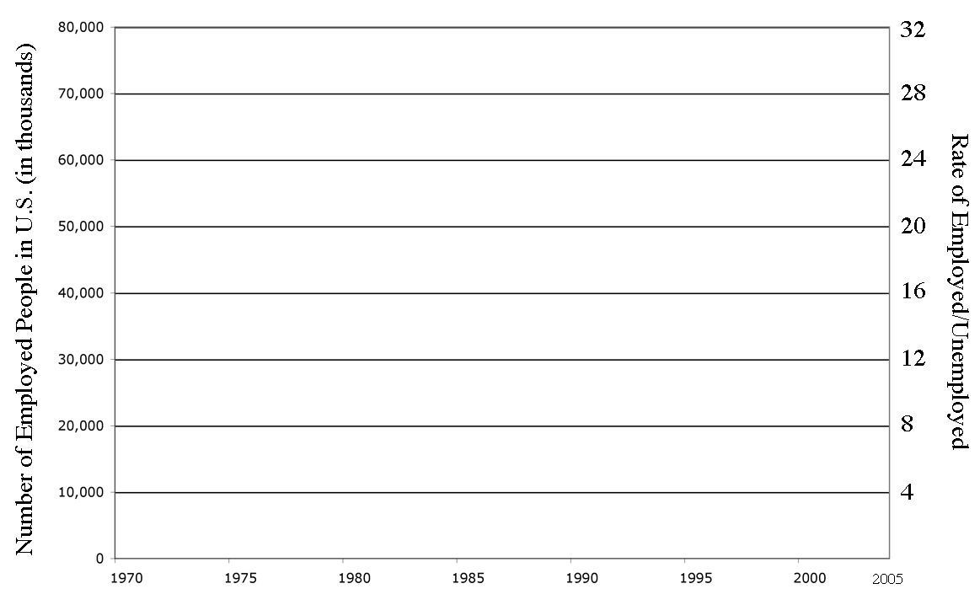

Look at your Line Graph, and re-read the first question. Do you still have the same answer, or has your opinion changed? What evidence do you have?

Why is a Line Graph the best type of graph for comparing these sets of data?

Today we’re going to explore what the U.S. Government spends money on, and how much money they spend on these items.

Go to the website: http://www.benjerry.com/americanpie/allocate.cfm. Once you get there, you should determine what percent of our Federal Budget you think should be spent on each of the following items:

- National Defense
- International Affairs
- General Science, Space, and Technology
- Natural Resources & Environment
- Transportation
- Education, Training, and Social Services
- Health
- Income Security
- Veterans Benefits & Services
- Administration of Justice
- Other

After you’ve made your graph, print it out, and then compare it to the correct graph. Then answer the following questions:

Which category did you give the highest percent to? Why?

Which category did you give the lowest percent to? Why?

In what ways was your graph similar to the actual graph?

In what ways was your graph different to the actual graph?

What did this activity teach you about how the U.S. spends it’s money?

Letters in first name | 3 | 4 | 5 | 6 | 7 | 8 | 9 | 10 | 11
Number of people
Percent of Total
Fill in the following chart:

Divide the circle into slices, one slice for each of the categories that have at least 1 person. Each slice should represent the values from the third row (percents). The slices should not all be the same size, because not all groups have the same number of people. So, you will need to come up with a method for making sure that the size of each slice accurately represents each group’s percent of the total.

When you are done, on a separate piece of paper, write a detailed explanation of the method you used to make sure the size of each slice accurately represents the size of the groups from above.

Below are three sets of data about the 5 boroughs. Your task is to use this data to make two pie graphs. You can either use the data directly as it is shown, or manipulate (change) the data somehow to make it easier to work with. For your assistance, the pie graphs are divided into 10 equal pieces – but you can ignore the slices if they confuse you. There are many ways to use this data to make pie graphs correctly.

2004 Data | Total Population | People of Color | Military Recruits
Bronx | 1,332,650 | 934,120 | 681
Brooklyn | 2,465,326 | 1,449,440 | 1051
Manhattan | 1,537,195 | 701,897 | 307
Queens | 2,229,379 | 1,246,794 | 803
Stat. Island | 443,728 | 98,975 | 140
NYC Total

Explain the method you used to make each Pie Graph. Be as detailed in your explanation as possible.

How do your two graphs compare to each other? What do their similarities and differences mean about the five boroughs of New York?

By looking at your graphs, how would you describe the relationship between the two sets of data?

Jose got the following quiz grades: 89, 92, 78, and 96. What grade would he need on his fifth and final quiz to finish with an average of an 88?

In a class of 21 students the average score on a math test was 77%. If Suzie Smart got 95% and Jack Average got 78%, find the average grade of the other 19 students.

Andy had an average of 87 on 4 tests What does he have to get on his next test to get an average of 90?

Find a set of five data values with modes 0 and 2, median 2, and mean 2. Explain how you found your answer.

The median of five numbers is 15. The mode is 6. The mean is 12. What are the five numbers?

Draw a Dot-Plot graph that would have the same Mean and Median.

Prove (using math) that this dot-plot has the same Mean and Median.

Explain (using words) why this dot-plot has the same Mean and Median.

The following chart lists the number of American soldiers who have died in Iraq during each month for the past year. (Source: http://www.globalsecurity.org/military/ops/iraq_casualties.htm)

Month | Casualties
October, ‘06 | 101
September | 69
August | 65
July | 42
June | 59
May | 69
April | 74
March | 30
February | 53
January | 61
December, ‘05 | 66
November | 83

On separate paper, please answer the following questions:

First, imagine you work for the army, and you need to put out a press release that states the average number of soldiers killed per month. What number would you choose as your average? Explain how you got this number, and why you chose this as your method.

Next, imagine you are working for an Anti-war organization, and you need to put out a press release that states the average number of soldiers killed per month. What number would you choose as your average? Explain how you got this number, and why you chose this as your method.

Were the two averages you chose the same, or different? Explain why.

The following is a description of the difference salaries that people make at COMPANY X. The contract for the workers has expired, and now their union is fighting against the owners of the company for a raise. The amount of the raise needs to be based on how much the workers are currently making, and the two sides are having a hard time trying to agree on how much that is.

Name | Position | Salary
Agustina | Worker | $22,000
Aixa | Vice President | $65,000
Alex | Manager | $55,000
Andy | Worker | $32,000
Christopher | Worker | $31,000
Florangel | President | $80,000
Gloria | Worker | $41,000
Gricel | Worker | $29,500
Guadalupe | Worker | $22,000
Hernis | Worker | $36,500
Joshua | Worker | $39,500
Juana | Manager | $57,500
Keith | Vice President | $60,000
Latoya | Worker | $29,500
Luis | Worker | $33,000
Manuel | Worker | $32,750
Melinda | Worker | $31,500
Melissa | Worker | $34,000
Mey-Ling | Worker | $38,500
Nickol | Worker | $36,250
Nicole | Worker | $27,000
Rosanna | Manager | $58,000
Stacy | Worker | $29,500
Tiffany | Worker | $32,000
William | Worker | $38,000

First, imagine that you are the negotiator for the Union that represents the workers. What would you say is the average salary for people that work at COMPANY X? Come up with a convincing argument for why this method should be used to determine the average. Show how you determined this average.

Next, imagine that you are the negotiator for the owners of the company. What would you say is the average salary for people that work at COMPANY X? Come up with a convincing argument for why this method should be used to determine the average. Show how you determined this average.

Which method do you think is the most fair for determining how much the workers make? Why?

For the first Senior Math Quarterly of the year, we will be having a debate about the unemployment rate in the United States. There is a lot of dispute about what the unemployment rate is and how it should be calculated.

The main debate questions you will need to answer are:
- What is the average rate of unemployment over the past year?
- Are Americans better off today than in the past in terms of jobs?

To answer these questions, you will be given several sets of data. It is up to you to decide which sets of data you will use, which data in your chosen sets you will analyze, and what type of math you will use to analyze this data.

For this debate, the class will be divided into four groups. Each group is going to represent a different organization, and will argue a different side of the issue. These organizations are:
- The Federal Government
- The National Association of Men (NAM)
- The Regional Governors Group
- The Alliance for the Advancement of Women (AAW)

Your goal will be to come up with an answer for the two debate questions that will support your organization. In order to do this, you will need to:
- Analyze unemployment data
- Make at least one graph
- Prepare a short presentation for the debate

On Friday, November 10th, the class will be divided into four groups. Each group will have one representative from each organization who will then debate against each other. There will also be a facilitator at each table to act as a Debate Moderator.

Here is the structure for class over the next four days:

Day 1:
- Determine what information you’re going to use and analyze
- Begin analyzing the data
Day 2:
- Finish data analysis
- Make graph(s)
Day 3:
- Prepare for debate
Day 4:
- Debate
Helpful Questions to Answer

Which organization are you working with?

Read the information about your organization. Does your organization want to find an average unemployment rate that is high or low? Why?

Step 1: Determine which charts will you be using to answer Question #1 and write their titles below.

Step 2: Using the data for the past year, calculate the average unemployment rate in 2006 (Question #1). Your work should be on a separate piece of paper.

Step 3: Answer Question #2: “Are Americans better off today than in the past in terms of jobs” by looking at historical data. Your work needs to be based upon mathematical analysis/calculations and should be on a separate piece of paper.

Step 4: Make a graph to help you answer Question #2. It can be any type of graph, although certain graphs will be more appropriate than others.

Step 5: Using index cards or a similar method, prepare for the debate by deciding what you are going to say, what information you’re going to use, how you will respond to other people’s questions for you, etc.
The Federal Government

On April 11th, 2006, the White House released a statement that said: “Despite the Democrat’s claims, President Bush’s policies are growing our economy.”

Imagine you are working with the team that made this statement.

You want the people of the United States to believe in their President, and to think that he is doing a good job. You want people to be satisfied with their leader and his policies. If people think there are a lot of problems in the country, than they will immediately blame the President.

One of the most important issues to the American people is the economy. People want to know that the economy is strong. So it is your task to convince them that the President’s policies are working and that the economy is doing well.
The National Association of Men

Imagine that you work for the National Association of Men (NAM), a group that wants to make life better for men in this country.

NAM wants to make sure that people in the U.S., especially men, have jobs. Their belief is that if men are working, they can take care of their families, will commit less crimes, pay child support, feel better about themselves, make the economy better, etc.

NAM wants the federal government and the public to support their work, but in order to get this support, NAM needs to make it clear that there is a problem. If NAM shows that all men are working and have good jobs, than they wont get any more help from the federal government. On the other hand, if NAM can show that men are not working and need some extra help, the organization can get a lot of financial support to help fix the problem.

Your goal is to make an argument that will help get the organization and their members the financial and public support that they want.
The Regional Governors Group

When a State is having economic problems, the federal government will often give them extra money to help get through the tough times. But there is not a lot of money available, so States are always trying to compete and fight for this small amount of money.

The Governor’s for each region in the country often get together as a team to help each other out. Imagine you are going to work for one of these regional groups – you will need to choose which one.

Your goal is to help the Governor’s from your chosen region make an argument that despite all of the “hard work” that they’ve been doing in their own State, that unfortunately the economy is not doing very well. If you can prove that there are more economic problems in your region than elsewhere, you will be able to get some of the additional money from the federal government.

Here are the regions within the United States:

Northeast
- New England - Connecticut, Maine, Massachusetts, New Hampshire, Rhode Island, Vermont
- Middle Atlantic - New Jersey, New York, Pennsylvania

Midwest
- East/North Central - Illinois, Indiana, Michigan, Ohio, Wisconsin
- West/North Central - Iowa, Kansas, Minnesota, Missouri, Nebraska, North Dakota, South Dakota
- South Atlantic - Delaware, District of Columbia, Florida, Georgia, Maryland, North Carolina, South Carolina, Virginia, West Virginia

South
- East/South Central - Alabama, Kentucky, Mississippi, Tennessee
- West/South Central - Arkansas, Louisiana, Oklahoma, Texas

West
- Mountain - Arizona, Colorado, Idaho, Montana, Nevada, New Mexico, Utah, Wyoming
- Pacific - Alaska, California, Hawaii, Oregon, Washington

The Alliance for the Advancement of Women

Imagine that you are working for the Alliance for the Advancement of Women (AAW), which is an organization that wants to make life better for women in the U.S.

AAW organization believes that women are still not receiving equal opportunities compared to other people in this country. They want to get new laws passed that would protect the rights of women, but in order to get these laws passed, AAW will need the support of the people to put pressure on the government. If the public feels that women are all doing well in this country, than they wont feel the need to help AAW get these new laws passed. However, if the public feels that women are still not receiving the same opportunities as other people, they will be more likely to support AAW.

As a member of AAW, it is your task to help get information to the public about the barriers that women are facing in the economy. If women’s economic situation appears to be good, than you wont get much help from people. But, if you can demonstrate that women’s economic situation is not good, it will help you gain a lot of public support for your legislation.

On the day of the debate each student will be grouped with 2 or 3 other students from different organizations.

You should design your presentation according to the structure described below. However, the moderator assigned to your group will guide you through the debate and the order of events.

Introduction (1 minute/presenter):

Each student will introduce him/herself and give his/her name and a brief description (in his/her own words) of the group that they are supporting.

Example: Good morning/afternoon, my name is __________ and I am representing the ____________, which [explain what your interest group does or for whom it advocates].

Presentation will take place in the following order:
1st—Federal Government
2nd—Regional Governors Group
3rd—National Association of Men
4th—Alliance for the Advancement of Women

Round 1: The Average Unemployment Rate (10 minutes/presenter)

Opening Statement (3 minutes)
- State the average unemployment rate you calculated for your interest group. You must use visual aids help illustrate your argument – where you got your data from, and what calculations you used.

In this part, do not reveal how you manipulated the data to support your argument. This will only discredit your argument or make it weaker.

- Explain why your interest group’s unemployment rate must be improved. What are the consequences to our society if it does not improve? Why is the improvement of your interest group’s unemployment rate more important or of greater consequence than the improvement of other interest groups?

- In the case of the Federal Government, explain how or why you think that the U.S. government is doing a good job at fighting unemployment.

It may help your argument to compare the unemployment rate given by the Federal Government to your organization’s unemployment rate. (Since the Federal Government is presenting first, you should write this unemployment rate down so that you can incorporate it into your own argument). Is your interest group’s unemployment rate higher than the national rate?

Writing Comments Questions (2 minutes/Presenter)

After a presentation, each student should take 3 minutes to write down some comments and/or questions that could challenge the current presenter’s argument. Then the next student should present.

Commenting/Questioning/ Responses (5 minuntes/Presenter):

After all students have presented, students (in the same order in which they presented), will have an opportunity to respond to the comments and questions of the other students. First, each student will ask the Federal Government at least one question or give at least one comment. After each comment/question, the representative from the Federal Government will have a chance to respond.

After the person from the Federal Government is challenged by everyone else, comments and questions will be directed at the Regional Governors Group, and so on.

It is not productive for students to ask the same presenter the same question. (For example, if Jonathan asks Jessica, “What type of average did you use to get your data?” then another student should not ask Jessica the same question. However, it would be OK to then ask Carlos the same question later). Thus, try your best to ask at least one question or give at least one comment that you think other students will not ask.

Round 2: Are Americans better off today? (10 minutes/presenter)
Following the same procedure from Round 1, presenters should discuss the second debate question:

“Are Americans better off today than in the past in terms of jobs?

Round 3: Discussion (Time permitting)

After Round 2, if time permits, students should continue questioning, commenting, and responding to each other. This can happen naturally in whatever way the conversation/argument may lead. Please remember the “one mic” policy, be respectful, use appropriate language, and keep comments relevant to the issue and data.

Commenting and questioning can continue for as long as it is productive and done respectfully. The moderator assigned to the group will let students know when the commenting/questioning component is finished.

Closing: (1 minute/presenter)

After the moderator has ended the commenting/questioning component, each student (in the reverse order in which they presented) will thank the other students for their attention and participation in the debate and briefly (in a few sentences) restate their position and the unemployment rate of their interest group.

Debate Checklist

Notecard #1: Description of your organization

Notecard #2: The average unemployment rate over the past year that you calculated, the data you used, and how you calculated the average

Calculations: You should have your calculations written out on a separate piece of paper to show to the rest of the group. This is how you are “proving” your answer is correct.

Notecard #3: 2 questions someone might ask to challenge you, and what your response would be.

Notecard #4: Your answer to Debate Question #2, and the work you did to get the answer

Calculations: You should have your calculations written out on a separate piece of paper to show to the rest of the group. This is how you are “proving” your answer is correct.

Notecard #5: 2 questions someone might ask to challenge you, and what your response would be.

Notecard #6: Closing Statement

Graph: You need at least one graph to help illustrate your answer to either the first or second question.

The chart below compares the median weekly income of men and women in 2000 in a number of different occupations. Find the 5 Number Summary for each group.

Occupation | Men | Women
Manager | 999 | 697
Executive | 995 | 684
Professional Specialty | 1001 | 708
Technical, sales, admin. Support | 653 | 451
Technicians | 754 | 539
Sales Occupations | 683 | 379
Administrative support, including clerical | 552 | 455
Service occupations | 405 | 313
Protective Service | 636 | 470
Precision production | 622 | 439
Mechanics and repairers | 645 | 588
Operators, fabricators, laborers | 492 | 353
Machine operators, assemblers, inspectors | 498 | 353
Transportation | 555 | 421
Handlers, equipment cleaners | 401 | 329
Farming, forestry, fishing | 342 | 288
Source: stats.bls.gov

The table below contains data on the percent of people in each Brooklyn Zip Code who identified themselves as Hispanic in the 2000 Census. Your task is to find the 5-Number Summary and any outliers of this data, and then to construct a Box-Plot.

Zip Code | % Hispanic
11201 - Brooklyn Heights/Cobble Hill | 14%
11203 - East Flatbush | 5%
11204 - Parkville/Bensonhurst | 7%
11205 - Fort Greene | 29%
11206 - Williamsburg/Bedford-Stuyvesant | 54%
11207 - East New York | 34%
11208 - Cypress Hills | 45%
11209 - Bay Ridge | 11%
11210 - Vanderveer | 7%
11211 - Williamsburg | 37%
11212 - Brownsville | 14%
11213 - Brower Park/Crown Heights | 8%
11214 - Bath Beach/Bensonhurst | 8%
11215 - Park Slope/Windsor Terrace | 27%
11216 - Bedford-Stuyvesant | 8%
11217 - Park Slope/Gowanus | 23%
11218 - Kensington/Windsor Terrace | 19%
11219 - Borough Park | 12%
11220 - Sunset Park | 47%
11221 - Bushwick/Bedford-Stuyvesant | 35%
11222 - Greenpoint | 20%
11223 - Gravesend/Homecrest | 10%
11224 - Coney Island | 18%
11225 - Crown Heights | 9%
11226 - Flatbush | 14%
11228 - Dyker Heights | 6%
11229 - Homecrest/Madison | 7%
11230 - Midwood | 8%
11231 - Carroll Gardens/Red Hook | 25%
11232 - Industry City/Sunset Park | 64%
11233 - Stuyvesant Heights | 13%
11234 - Flatlands/Mill Basin | 7%
11235 - Sheepshead Bay/Brighton Beach | 9%
11236 - Canarsie | 9%
11237 - Bushwick | 80%
11238 - Prospect Heights | 12%
11239 - Starrett City | 18%

Source: Infoshare.org

Your task is to construct 2 side-by-side Box Plots of the following data.

Zip Code | Percent of Females 25+ with Bachelors Degree | Percent of Males 25+ with Bachelors Degree
10001 - Fur-Flower District | 31% | 32%
10002 - Chinatown/Lower East Side | 10% | 11%
10003 - Cooper Square/Union Square | 40% | 39%
10004 - Battery/Governors Island | 44% | 41%
10005 - Wall Street | 39% | 51%
10006 - Trinity | 42% | 40%
10007 - City Hall | 37% | 22%
10009 - East Village/Stuyvesant Town | 25% | 28%
10010 - Madison Square/Cooper Village | 36% | 37%
10011 - Chelsea | 34% | 39%
10012 - Village/Noho/Soho | 34% | 35%
10013 - Tribeca/Chinatown | 24% | 21%
10014 - Greenwich Village | 41% | 42%
10016 - Murray Hill | 42% | 38%
10017 - Grand Central/United Nations | 45% | 38%
10018 - Garment District | 31% | 30%
10019 - Midtown/Clinton | 35% | 36%
10021 - Lenox Hill | 40% | 36%
10022 - Sutton Place/Beekman Place | 39% | 39%
10023 - Lincoln Center/Ansonia | 35% | 35%
10024 - Upper West Side | 34% | 35%
10025 - Cathedral | 25% | 27%
10026 - Central Harlem, South | 12% | 12%
10027 - Manhattanville | 13% | 13%
10028 - Yorkville | 41% | 38%
10029 - East Harlem, South | 8% | 8%
10030 - Central Harlem, Middle | 7% | 9%
10031 - Hamilton Heights | 8% | 7%
10032 - South Washington Heights | 8% | 9%
10033 - Washington Heights | 10% | 11%
10034 - Inwood | 12% | 12%
10035 - East Harlem, Middle | 5% | 6%
10036 - Theatre District/Clinton | 35% | 34%
10037 - East Harlem, North | 12% | 10%
10038 - South St. Seaport/Chinatown | 19% | 25%
10039 - Central Harlem, North | 7% | 6%
10040 - North Washington Heights | 11% | 11%
10044 - Roosevelt Island | 21% | 23%
10128 - Yorkville | 37% | 35%
10280 - Battery Park City | 33% | 37%

Your task is to construct 2 side-by-side Box Plots of the following data.

Zip Code | Percent of Females 25+ with Bachelors Degree | Percent of Males 25+ with Bachelors Degree
10451 - Melrose | 8% | 5%
10452 - Highbridge | 5% | 3%
10453 - Morris Heights | 6% | 4%
10454 - Mott Haven/Port Morris | 3% | 3%
10455 - The Hub/Longwood | 5% | 4%
10456 - Morrisania | 5% | 5%
10457 - Tremont/East Tremont | 5% | 5%
10458 - Belmont/Fordham/Bedford Park | 7% | 8%
10459 - Longwood/Morrisania | 5% | 4%
10460 - West Farms/Crotona | 6% | 5%
10461 - Westchester/Morris Park | 12% | 14%
10462 - Parkchester/Van Nest | 12% | 12%
10463 - Kingsbridge (full) | 0% | 0%
10464 - City Island | 12% | 17%
10465 - Throgs Neck/Country Club | 10% | 10%
10466 - Wakefield | 11% | 11%
10467 - Norwood/Williamsbridge | 11% | 9%
10468 - University Heights | 8% | 8%
10469 - Williamsbridge/Baychester | 13% | 12%
10470 - Woodlawn/Wakefield | 14% | 12%
10471 - Riverdale/Fieldston | 19% | 23%
10472 - Soundview | 7% | 6%
10473 - Clasons Point | 8% | 7%
10474 - Hunts Point | 4% | 2%
10475 - Co-op City/Eastchester | 15% | 12%

Your task is to construct 2 side-by-side Box Plots of the following data.

Zip Code | Percent of Females 25+ with Bachelors Degree | Percent of Males 25+ with Bachelors Degree
11001 - Floral Park | 24% | 22%
11004 - Glen Oaks | 19% | 22%
11101 - Long Island City/Hunters Point | 13% | 13%
11102 - Old Astoria | 17% | 20%
11103 - Astoria | 15% | 16%
11104 - Sunnyside | 17% | 18%
11105 - Steinway | 17% | 21%
11106 - Ravenswood | 16% | 19%
11354 - Flushing | 15% | 20%
11355 - Flushing/Murray Hill | 17% | 19%
11356 - College Point | 13% | 13%
11357 - Whitestone | 14% | 20%
11358 - Auburndale | 17% | 20%
11360 - Bay Terrace | 22% | 27%
11361 - Bayside | 19% | 23%
11362 - Little Neck | 19% | 25%
11363 - Douglaston | 21% | 31%
11364 - Oakland Gardens/Bayside Hill | 21% | 26%
11365 - Fresh Meadows | 18% | 22%
11366 - Utopia/Fresh Meadows | 19% | 24%
11367 - Kew Garden Hills | 18% | 21%
11368 - Corona | 8% | 7%
11369 - East Elmhurst | 9% | 8%
11370 - Jackson Heights-Rikers Island | 13% | 15%
11372 - Jackson Heights | 13% | 15%
11373 - Elmhurst | 15% | 16%
11374 - Rego Park | 23% | 28%
11375 - Forest Hills | 26% | 28%
11377 - Woodside | 15% | 16%
11378 - Maspeth | 10% | 10%
11379 - Middle Village | 11% | 15%
11385 - Ridgewood/Glendale | 9% | 9%
11411 - Cambria Heights | 15% | 17%
11412 - St. Albans | 12% | 11%
11413 - Springfield Gardens/Laurelton | 14% | 14%
11414 - Howard Beach | 11% | 14%
11415 - Kew Gardens | 22% | 23%
11416 - Ozone Park/Woodhaven | 6% | 6%
11417 - Ozone Park | 7% | 9%
11418 - Richmond Hill | 12% | 13%
11419 - South Richmond Hill | 7% | 10%
11420 - South Ozone Park | 9% | 10%
11421 - Woodhaven | 12% | 13%
11422 - Rosedale | 14% | 13%
11423 - Hollis/Holliswood | 14% | 14%
11426 - Bellerose | 17% | 19%
11427 - Queens Village/Creedmoor | 17% | 20%
11428 - Queens Village | 13% | 15%
11429 - Queens Village (South) | 13% | 11%
11430 - JFK Airport | 0% | 0%
11432 - Jamaica/Hillcrest | 18% | 18%
11433 - South Jamaica | 9% | 8%
11434 - Rochdale/Baisley Park | 11% | 9%
11435 - Jamaica Hills/South Jamaica | 12% | 14%
11436 - South Ozone Park | 10% | 8%
11691 - Far Rockaway | 9% | 10%
11692 - Arverne | 8% | 8%
11693 - Hammels/Broad Channel | 10% | 9%
11694 - Seaside/Belle Harbour/Neponsit | 15% | 22%
11697 - Rockaway Point/Roxbury | 18% | 21%

Your task is to construct 2 side-by-side Box Plots of the following data.

Zip Code | Percent of Females 25+ with Bachelors Degree | Percent of Males 25+ with Bachelors Degree
11201 - Brooklyn Heights/Cobble Hill | 27% | 26%
11203 - East Flatbush | 12% | 9%
11204 - Parkville/Bensonhurst | 12% | 13%
11205 - Fort Greene | 14% | 14%
11206 - Williamsburg/Bedford-Stuyvesant | 5% | 5%
11207 - East New York | 7% | 5%
11208 - Cypress Hills | 6% | 6%
11209 - Bay Ridge | 21% | 23%
11210 - Vanderveer | 14% | 17%
11211 - Williamsburg | 11% | 14%
11212 - Brownsville | 6% | 5%
11213 - Brower Park/Crown Heights | 8% | 8%
11214 - Bath Beach/Bensonhurst | 13% | 15%
11215 - Park Slope/Windsor Terrace | 27% | 27%
11216 - Bedford-Stuyvesant | 9% | 6%
11217 - Park Slope/Gowanus | 26% | 28%
11218 - Kensington/Windsor Terrace | 15% | 16%
11219 - Borough Park | 7% | 10%
11220 - Sunset Park | 8% | 8%
11221 - Bushwick/Bedford-Stuyvesant | 6% | 6%
11222 - Greenpoint | 11% | 14%
11223 - Gravesend/Homecrest | 13% | 15%
11224 - Coney Island | 13% | 14%
11225 - Crown Heights | 10% | 9%
11226 - Flatbush | 8% | 8%
11228 - Dyker Heights | 12% | 17%
11229 - Homecrest/Madison | 16% | 20%
11230 - Midwood | 16% | 19%
11231 - Carroll Gardens/Red Hook | 22% | 28%
11232 - Industry City/Sunset Park | 8% | 9%
11233 - Stuyvesant Heights | 7% | 7%
11234 - Flatlands/Mill Basin | 15% | 15%
11235 - Sheepshead Bay/Brighton Beach | 17% | 20%
11236 - Canarsie | 12% | 13%
11237 - Bushwick | 5% | 4%
11238 - Prospect Heights | 19% | 21%
11239 - Starrett City | 8% | 12%

Your task is to construct 2 side-by-side Box Plots of the following data.

Zip Code | Percent of Females 25+ with Bachelors Degree | Percent of Males 25+ with Bachelors Degree
10301 - New Brighton/Grymes Hill | 17% | 19%
10302 - Port Richmond | 9% | 9%
10303 - Mariners Harbour/Point Ivory | 10% | 10%
10304 - Stapleton/Fox Hills | 13% | 15%
10305 - Rosebank | 12% | 12%
10306 - New Dorp/Richmondtown | 11% | 14%
10307 - Tottenville | 13% | 14%
10308 - Great Kills | 10% | 18%
10309 - Princes Bay/Woodrow | 13% | 16%
10310 - West New Brighton | 13% | 16%
10312 - Eltingville/Annadale | 13% | 17%
10314 - Castleton Corners/New Springville | 14% | 18%

Remember to use the same scale for both Box Plots.

Males |  |  | Females

Median Household Income in the U.S., by Region (2004 dollars) 1989-2004

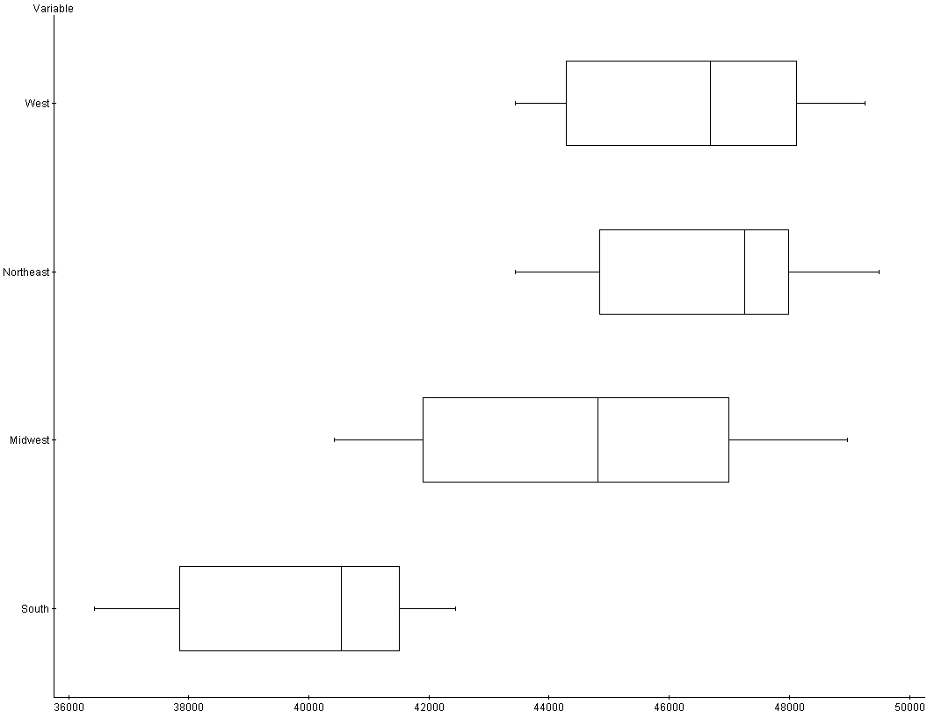
Source: http://www.census.gov/hhes/income/histinc/h08.html

What does it mean when the graph refers to “2004 dollars” if the data is based on median incomes from the years 1989 through 2004?

Which part of the country has the most variability in terms of median incomes over the years? Please make a guess as to why there might be such variability.

Which region of the country has the highest median incomes during this time? How do you know your answer is correct?

Which region of the country would you say is the poorest? How do you know your answer is correct?

Write 3 other things you can tell about income in the U.S. from looking at the box-plots.
Sc

Miguel gave out a survey to some of his friends. He asked people this question:

“On a scale from 1 to 10, what do you think of the school lunch? 1 means you
hate it, and 10 means you love it.”

8 males and 11 females responded to his survey. Here are the results of his survey:

 | Males | Females
 | 6 | 7
 | 5 | 4
 | 8 | 8
 | 7 | 3
 | 6 | 5
 | 8 | 8
 | 2 | 4
 | 3 | 7
 |  | 9
 |  | 1
 |  | 2
Mean:
Standard Deviation:

On the back of this paper, calculate the Mean and Standard Deviation for each gender.

What can you determine about how the two genders compare to each other by looking at their means and Standard Deviations?

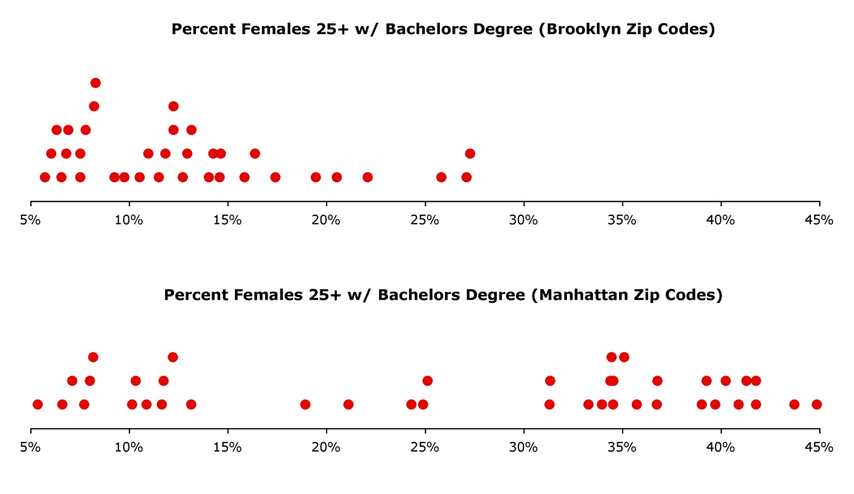

For each of these Dot Plots, figure out (or guess) the answers that would fit in this chart. You have 5 minutes to do this.

 | Brooklyn | Manhattan
Mean
Smallest Value
Q1
Median
Q3
Largest Value
Standard Deviation

Teen Gun-Related Homicide Rates, per 100,000 (1976-2004)

Year | NE | MA | ENC | WNC | SA | ESC | WSC | MT | PA | US
1976 | 1.3 | 5.4 | 9.4 | 4.3 | 5.9 | 5.5 | 5.5 | 4.1 | 7.8 | 6.4
1977 | 1.1 | 5.7 | 8.2 | 3.3 | 7.7 | 6.8 | 7.3 | 3.1 | 9 | 6.6
1978 | 1.4 | 5 | 6.5 | 3.1 | 5.7 | 5.8 | 7.3 | 5 | 7.6 | 5.7
1979 | 1.8 | 8.3 | 8.2 | 3.7 | 5.8 | 5.1 | 7.2 | 2.9 | 11.6 | 7.1
1980 | 1.7 | 7 | 6.3 | 3.2 | 5.8 | 5.4 | 8.5 | 6.1 | 17.1 | 7.5
1981 | 1.5 | 7.5 | 7.2 | 2.8 | 5.3 | 4.8 | 7.8 | 2.6 | 15.6 | 7.4
1982 | 3.3 | 6.1 | 6.8 | 3.7 | 4.3 | 2.9 | 5.8 | 5.2 | 10.5 | 6.2
1983 | 1.6 | 7.2 | 5.7 | 2.9 | 3.6 | 4.6 | 6.4 | 2.7 | 9.5 | 5.7
1984 | 1.2 | 5.4 | 6.3 | 2 | 4.2 | 4 | 7.4 | 4.5 | 8.9 | 5.3
1985 | 4.3 | 5.5 | 6.3 | 1.8 | 7.8 | 6.4 | 7.9 | 2.3 | 9.9 | 6.5
1986 | 2.9 | 7.9 | 8.6 | 2.4 | 7.2 | 6.6 | 8.6 | 6.1 | 11.4 | 7.6
1987 | 2.8 | 9 | 9 | 3.3 | 8.4 | 5.3 | 7.6 | 2.7 | 14.1 | 8.4
1988 | 7.1 | 14.5 | 10.1 | 2.6 | 9.6 | 8.8 | 15.1 | 5.6 | 16.6 | 11.6
1989 | 8 | 14.2 | 13.3 | 5.8 | 15.2 | 9.9 | 16 | 4.1 | 22.5 | 13.9
1990 | 11.2 | 22.2 | 19.6 | 6 | 17 | 11.9 | 25.3 | 6.7 | 29.3 | 19.6
1991 | 8.3 | 22 | 23 | 11.4 | 24.5 | 21 | 28.9 | 7.1 | 29.1 | 22
1992 | 12.8 | 22.4 | 22.8 | 11.3 | 24.8 | 15 | 34.6 | 9.3 | 29.7 | 22.8
1993 | 12.4 | 22.2 | 27.6 | 17.3 | 27.6 | 18 | 37 | 12.5 | 33 | 25.7
1994 | 9.4 | 21.2 | 29.9 | 15 | 24 | 21.8 | 37.8 | 17.4 | 31.5 | 25.8
1995 | 6.5 | 14.5 | 24.2 | 12 | 19.2 | 17.1 | 27.5 | 13.3 | 27.2 | 20
1996 | 5.9 | 11.6 | 22.2 | 7.2 | 13.4 | 15 | 20.7 | 13.9 | 17.2 | 15.8
1997 | 6.2 | 9.2 | 18.9 | 6.5 | 18 | 14.8 | 15.5 | 8.5 | 14.6 | 13.7
1998 | 1.8 | 8.1 | 11.5 | 6.3 | 9.3 | 10.6 | 11.8 | 9.5 | 11.9 | 10
1999 | 4.4 | 6.8 | 8.3 | 2.4 | 12.3 | 11.4 | 8.2 | 6.8 | 7.1 | 7.9
2000 | 2.2 | 4.6 | 7.9 | 5.2 | 8.7 | 4.7 | 8.4 | 4.2 | 7.6 | 6.7
2001 | 2.2 | 3.9 | 6.2 | 3 | 9.7 | 7.4 | 5.9 | 4.7 | 6.9 | 6.3
2002 | 2.3 | 4.6 | 6.1 | 2.4 | 8.9 | 6 | 4.7 | 3.9 | 9.4 | 6.2
2003 | 2.8 | 5 | 7 | 1.6 | 8.3 | 7.3 | 8.3 | 7 | 6.5 | 6.5
2004 | 0.4 | 5.9 | 6.7 | 4.9 | 6.6 | 4.6 | 7.2 | 5 | 8.2 | 6.2

Available for download: www.radicalmath.org/docs/Seminar2Data.xls

NE New England Connecticut, Maine, Massachusetts, New Hampshire, Rhode Island, Vermont
MA Middle Atlantic New Jersey, New York, Pennsylvania
ENC East North Central Illinois, Indiana, Michigan, Ohio, Wisconsin
WNC West North Central Iowa, Kansas, Minnesota, Missouri, Nebraska, North Dakota, South Dakota
SA South Atlantic Delaware, District of Columbia, Florida, Georgia, Maryland, North Carolina, South Carolina, Virginia, West Virginia
ESC East South Central Alabama, Kentucky, Mississippi, Tennessee
WSC West South Central Arkansas, Louisiana, Oklahoma, Texas
MT Mountain Arizona, Colorado, Idaho, Montana, Nevada, New Mexico, Utah, Wyoming
PA Pacific Alaska, California, Hawaii, Oregon, Washington
Your task is to answer the following question:

How is the United States doing at bringing down the teenage gun-related murder rate?

You have data for 9 different regions in the U.S., as well as for the U.S. as a whole, from 1976 to 2004.

You can use any/all of the math that we’ve used this year to help you further understand and analyze this data, including:
- Percent Growth
- Averages
- 5 Number Summaries and Outliers
- Standard Deviation

You should also make graphs that will help illustrate your findings. These could/should include:
- Dot Plots
- Bar Graphs
- Histograms
- Line Graphs
- Box Plots
- Pie Graphs (?)

As a class, we will have a discussion about this data. You are all expected to participate in the discussion. When you talk during the conversation, your goal is to further the discussion about the question from above. When you talk, you can:

  - Answer the question from above. Make sure that you refer to the data, your calculations, or your graphs, when making a point.

  - You can also pose a question to another student to clarify something they said.

  - You can also state what other data you would like to make a more informed opinion to this question.

Your assignment for this part of your Graduation Portfolio in Math is to analyze two related sets of data, one about females and one about males, for one of the five boroughs in NY. Your goal is to be able to use what you’ve learned in class this year to analyze the data and then explain what you can determine about the situation for males, the situation for females, and a comparison between the two (looking at similarities and differences)

Part 1: Rates
Once you are given the data, you will need to convert the totals into rates. You should choose a rate that makes sense given the scale of the data (out of 100? 1,000? more than 1,000?)

Part 2: Mathematical Analysis
In order to understand more about the data you have, you will need to do perform some statistical analysis. The more analysis you do, the more thoughtfully you will be able to reflect on your data. We have studied the following forms of statistical analysis so far:
- Averages
- 5 Number Summaries
- Standard Deviation

Part 3: Graphing
You need to make two graphs from the rates you’ve calculated; each graph should contain both sets of data that you are working with. The types of graphs we’ve made are:
- Dot Plots
- Bar Graphs
- Histograms
- Line Graphs
- Pie Graphs
- Box Plots

Each graph must have a paragraph accompanying it that explains:
- Why you chose this type of graph
- What the graph helps you understand about your data – about each gender and/or a comparison between the two genders.
Part 4: Write Up
The write-up for this project should include the following:

- Results/Key Findings – A Key Finding is something you have discovered about your data that you think is important.

A Key Finding can be:
- A value that is much higher or lower than the other values
- A value that surprises you
- An average or another number that summarizes all or parts of your data

Key Findings can be about:
- An entire category (ex. “Males” or “all of Queens” or “Williamsburg”)
  - “The average for the borough of Queens was 297”
- A comparison between two pieces of data:
  - “The rate for males was only 3.5, whereas the rate for females was much higher at 7.8”

When writing your Key Findings, you need to state:
- A number (or numbers)
- A description of what the number(s) represents
- A sentence about why this Key Finding is important. For example:
  - BAD: “The median income was $29,500”
  - BETTER: “The median income was $29,500 for women in Queens”
  - BEST: “The median income was $29,500 for women in the Bronx. I think this is interesting because this is much lower than the median for all of NYC ($39,000)”

Part 5: CONCLUSION
This is an opportunity to reflect on the part of the Statistics Unit we’ve just finished. Your response should be in Essay Form, but here are some questions you can use to help:
- Have you enjoyed this unit so far? What about it have you liked/disliked?
- What new skills have you learned? What are you still confused about?
- How have you become a better student since last year? What do you still need to work on?
- Do you feel that you have learned about social justice issues in this class, in addition to new math skills and ideas? Which social justice issues have you enjoyed learning about? Why?
- What are your goals for next unit?

Timeline for Project

Due Date (TEAM I) | Due Date (TEAM H) | What is Due:
Thursday, November 30th | Monday, December 4th | Portfolio Assigned
Friday, December 1st | Wednesday, December 6th | Calculations (Rates)
Monday, December 4th | Wednesday, December 6th | Calculations (Statistical Analysis)
Wednesday, Dec 6th | Friday, December 8th | Graphs
Friday, Dec 8th (or before) | Monday, December 11th | Write-Up

